http://www.usccb.org/beliefs-and-teachings/how-we-teach/new-evangelization/jubilee-of-mercy/the-corporal-works-of-mercy.cfm

The Corporal Works of Mercy

The Corporal Works of Mercy
The Corporal Works of Mercy are found in the teachings of Jesus and give us a model for how we should treat all others, as if they were Christ in disguise. They "are charitable actions by which we help our neighbors in their bodily needs" (USCCA). They respond to the basic needs of humanity as we journey together through this life.
The seven Corporal Works of Mercy are listed below. After each work of mercy there are also suggestions and words of advice for living them out in our daily lives. Have your own suggestions? Let us know @USCCB and use the hashtag #mercyinmotion.

FEED THE HUNGRY
There are many people in this world who go without food. When so much of our food goes to waste, consider how good stewardship practices of your own food habits can benefit others who do not have those same resources. 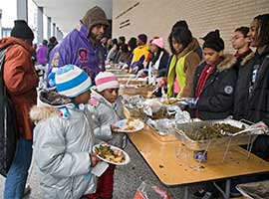
- Having delicious food at Thanksgiving or Christmas dinner? Donate to a Thanksgiving or Christmas food drive so everyone can have something to eat.
- Research, identify and contribute financially to organizations that serve the hungry.
- The next time you make a recipe that can be easily frozen, make a double batch and donate one to your local food pantry or soup kitchen.
- Try not to purchase more food than you are able to eat. If you notice that you end up throwing groceries away each week, purchasing less groceries would eliminate waste and allow you to donate the savings to those in need.

GIVE DRINK TO THE THIRSTY
Many of our brothers and sisters in Christ do not have access to clean water and suffer from the lack of this basic necessity. We should support the efforts of those working towards greater accessibility of this essential resource.
- We take it for granted that we have access to clean water. Donate. . . to help build wells for water for those in need
- Organize a group of children involved on a sports team (e.g. soccer) or a summer camp. Invite them to collect bottled water to distribute at a shelter for families. If parents can be involved, ask them to accompany their children in delivering the water to the families.
- Do the same for youth and young adult groups.
- Make an effort not to waste water. Remembering to turn off the water faucet when you are brushing your teeth or washing dishes can help, especially in regions suffering from drought.

SHELTER THE HOMELESS
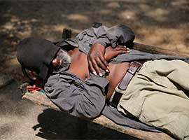There are many circumstances that could lead to someone becoming a person without a home. Christ encourages us to go out and meet those without homes, affirming their worth and helping them seek a resolution to the challenges they face.
- See if your parish or diocese is involved with a local homeless shelter and volunteer some time.
- Donate time or money to organizations that build homes for those who need shelter.
- Many homeless shelters need warm blankets for their beds. If you can knit or sew that would be an extra loving gift.
- There are millions of children and families who are on the move, fleeing from war, illness, hunger and impossible living conditions, and searching for peace and safety. Engage parish groups of children, youth, young adults, and families in doing some research on the causes and challenges that these families face to survive. Contact Catholic Social Services, or diocesan offices of peace and justice for help with your research. Seek ways to provide shelter for the homeless locally, regionally, nationally or internationally.

VISIT THE SICK
Those who are sick are often forgotten or avoided. In spite of their illness, these individuals still have much to offer to those who take the time to visit and comfort them.
- Give blood
- Spend time volunteering at a nursing home – Get creative and make use of your talents (e.g. sing, read, paint, call Bingo, etc.)!
- Take time on a Saturday to stop and visit with an elderly neighbor.
- Offer to assist caregivers of chronically sick family members on a one-time or periodic basis. Give caregivers time off from their caregiving responsibilities so they can rest, complete personal chores, or enjoy a relaxing break.
- Next time you make a meal that can be easily frozen, make a double batch and give it to a family in your parish who has a sick loved one.

VISIT THE PRISONERS
People in prison are still people, made in the image and likeness of God. No matter what someone has done, they deserve the opportunity to hear the Word of God and find the Truth of the message of Christ.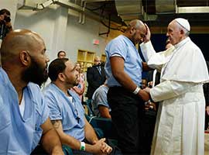
- See if your parish, or a nearby parish, has a prison ministry and if so, get involved.
- Volunteer to help out or donate to charities that give Christmas presents to children whose parents are in prison.

BURY THE DEAD
Funerals give us the opportunity to grieve and show others support during difficult times. Through our prayers and actions during these times we show our respect for life, which is always a gift from God, and comfort to those who mourn.
- Send a card to someone who has recently lost a loved one. Make your own card and use some of these prayers.
- Visit the cemetery and pray for those you have lost.
- Spend time planning your own funeral mass, read through the Order of Christian Funerals and find our hope in the Resurrection.

GIVE ALMS TO THE POOR
Donate money to organizations that have the ability to provide support and services for those in need. Do research and find organizations that put people in need first, rather than profit.

